Manual test plan for 3.2

1. Navigate to a project page
2. To the right of the files list, ensure you see a comment count.
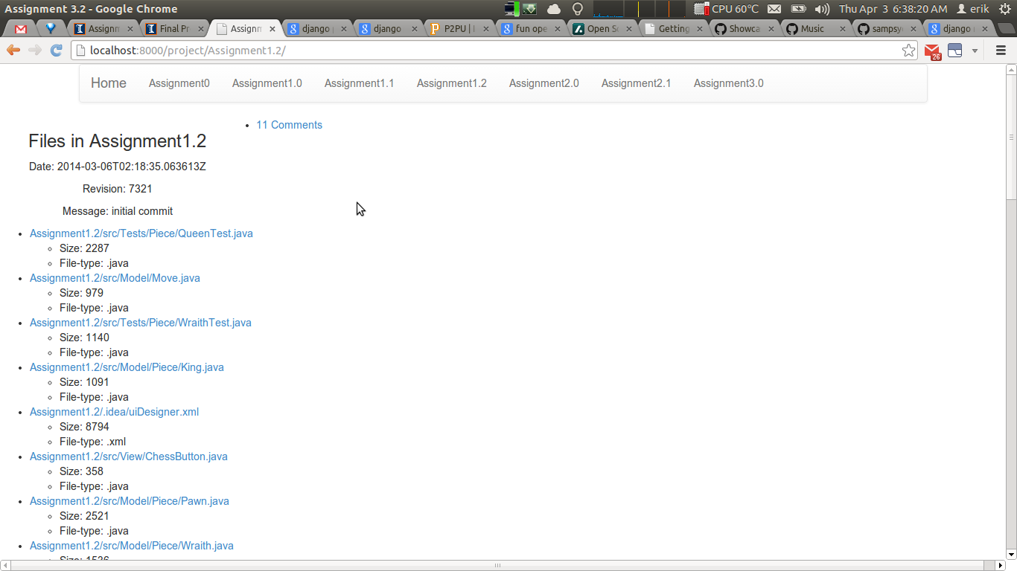
3. Ensure clicking on the number of comments loads the page of comments
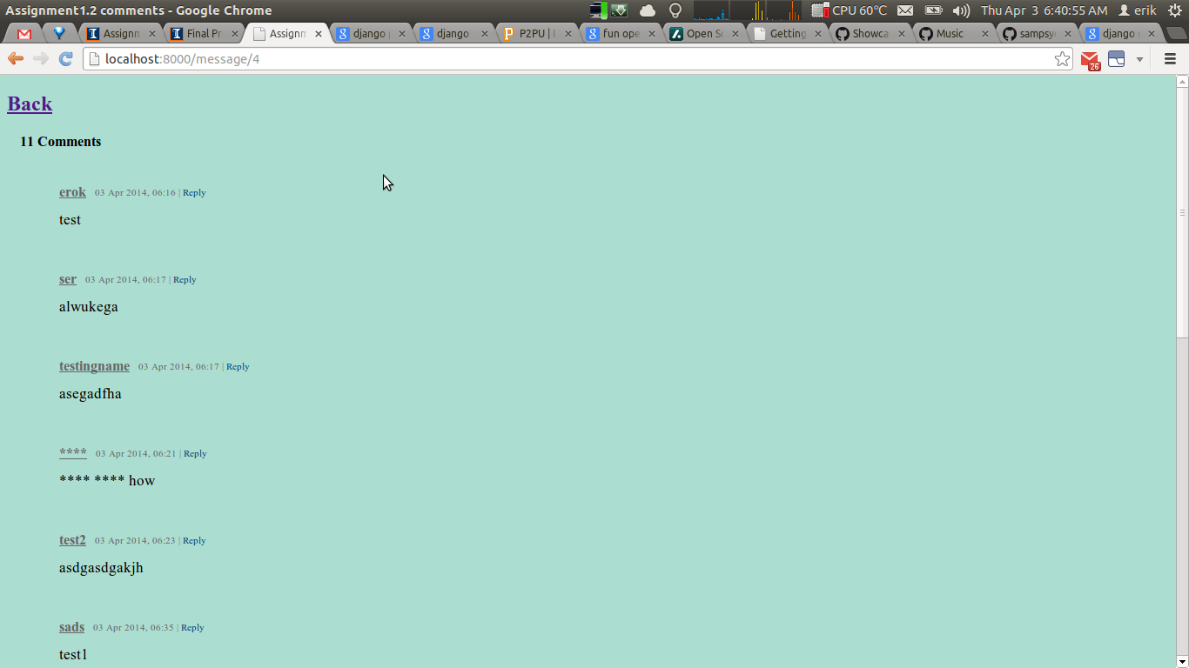

4. Ensure there is a form to post comments at the bottom of the page
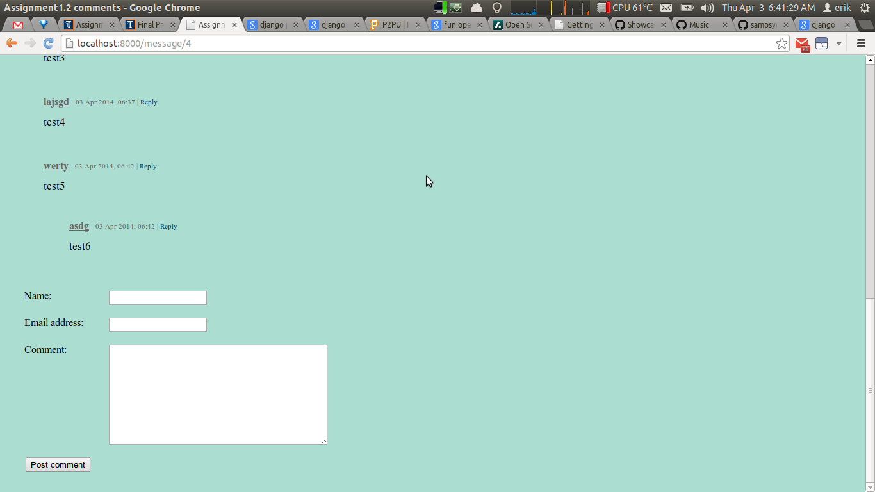
5. Fill out the name, email, and comment fields and then click the “Post comment”. Ensure that your comment appears on the page without refreshing
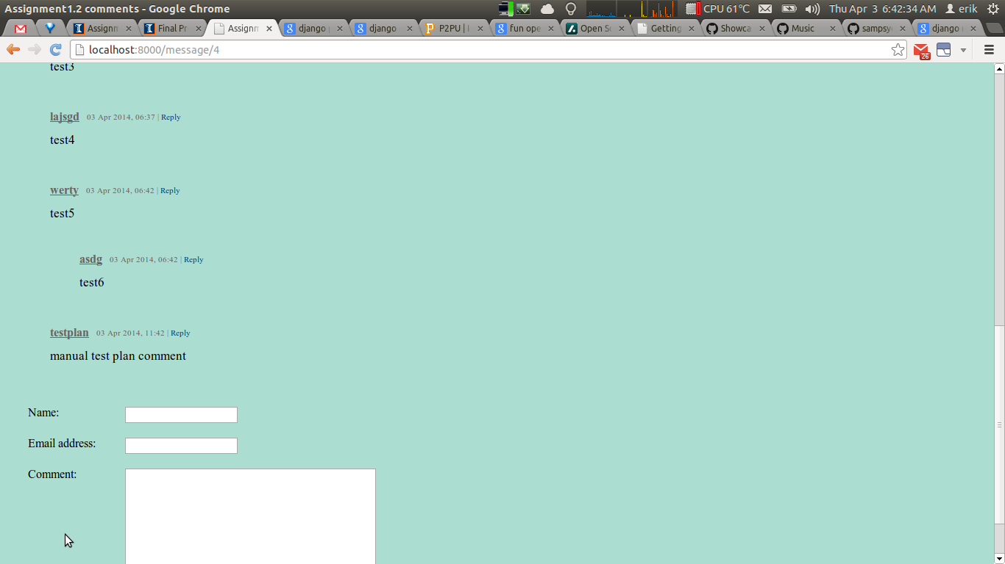

6. Click “Back” at the top of the page and ensure you are returned to the project page

7. Click on one of the files listed on the project page. You should now see a page like this
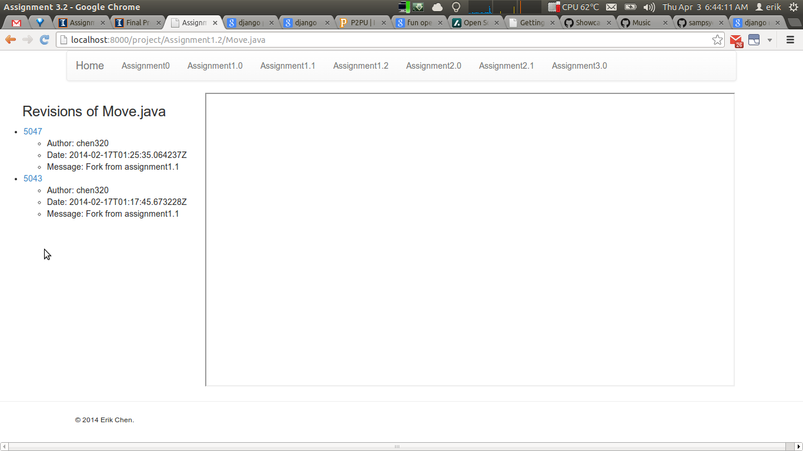
8. Click on a revision number. The contents of the file should be now visible in the frame on the right.
